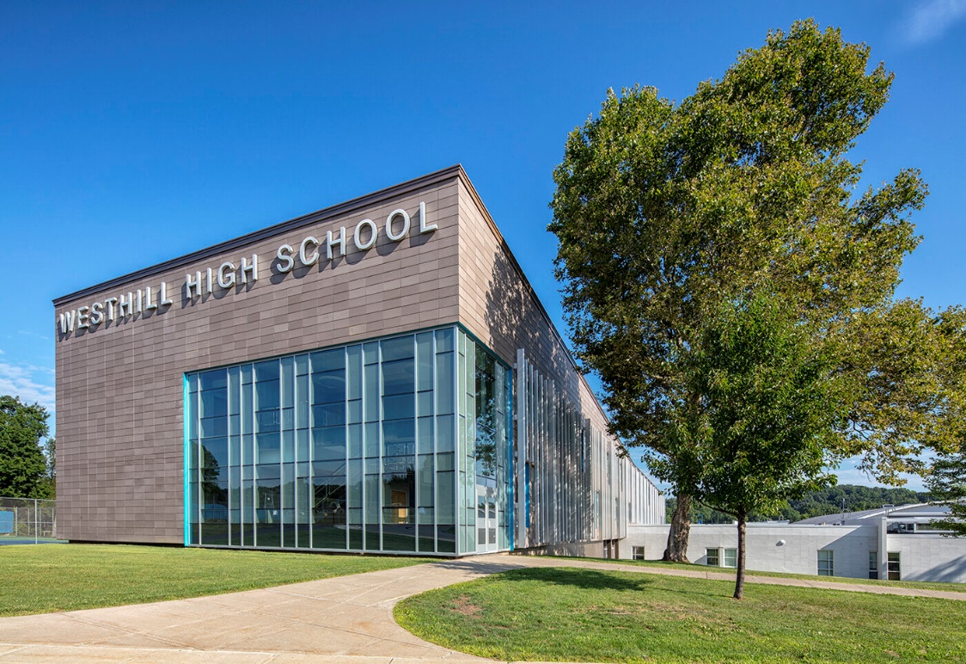

MINIMUM CAPACITY :-

The Minumum intake capacity

of students is between 350-620

children

LIBRARY :-

The Libarary is Available.

CANTEEN:-

The Canteen Facility is Available.

BOARDING :-

No availablility of boarding.

SPORTS :-

There are different categories

sports available.

Girls Volleyball

Boys Volleyball

Football

|  |  |  |
| --- | --- | --- |
| WESTHILL SENIOR HIGH SCHOOL SYRACUSE - SCHOOL |  |  |
|  |  |  |
| School Detail :- Westhill Senior High School is a public high school located in the western suburbs of, and immediately adjacent to, the City of Syracuse, New York. It serves grades 9 through 12, primarily from the neighborhood of Westvale, as well as portions of the Onondaga Hill area.  Established in 1963 as Westhill Junior-Senior High School serving grades 7-12 at the time, Westhill High School maintains a local reputation in the Syracuse area for having a high graduation rate, a large percentage of graduates attending college, and a successful athletic program. |  |
|